**Automate a Web Browser functionality Using Selenium**

**Requirements:**

* Functional Jupyter notebook environment
* Chrome browser
  + Version can be checked by clicking “Settings” and then “About Google Chrome”

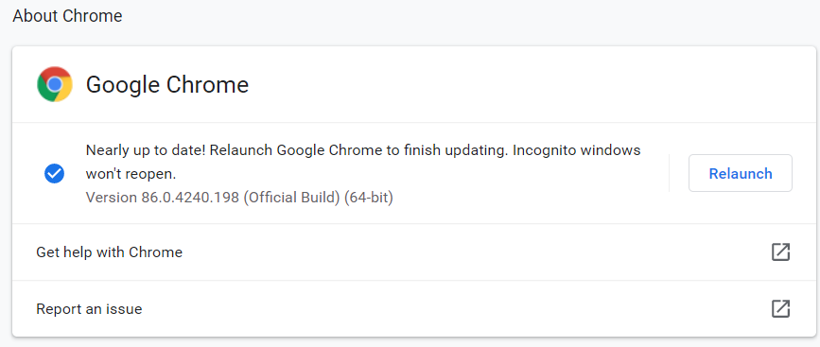

* Download the Chrome Web Driver from this website:
  + <https://chromedriver.chromium.org/home>
  + Please note that the Google Chrome Browser version should match with the Chrome web Driver version
  + This file should be extracted and the extracted file should be placed at an accessible location
  + This location would be passed as the PATH of the web driver in the code

**Steps of execution:**

1. After the above requirements are satisfied the code is just one click run
2. The code is distributed across three chunks
   1. The first chunk is where all the import statements are declared
   2. The second chunk is where the web driver location is defined and the driver object is declared
   3. The third chunk is the meat of the code
      1. The actual functionality is executed by this chunk
      2. Initially this chunk loads the website: <http://awardsdatabase.oscars.org>
      3. After the website is loaded it proceeds on to click year from: 2010 and year to: 2019
      4. Then it hits search
      5. Once the search results are loaded the code searched for “Javier Bardem”
      6. Accordingly the link containing “Javier Bardem” is clicked and loaded
3. Wait.until statements have been added in the code at all places so that they take care of any page-loading delays